**CE-Certified and Market-Ready**

**Escarda Technologies' Laser Weed Control System**

***Sustainable, Herbicide-Free Weed Control with AI: After an intensive pilot phase, Escarda Technologies is officially launching its CE-certified laser system.***

Berlin, 8 April 2025 – **Sustainable, Herbicide-Free Weed Control with AI:** After an intensive pilot phase, Escarda Technologies is officially launching its CE-certified laser system.

Berlin, April 2025 – Following intensive development and testing, Escarda Technologies is now introducing its CE-certified laser weed control system to the market. As a pioneer in this field, the Berlin-based company identified early on the need for an efficient, herbicide-free solution. The AI-powered technology eliminates weeds safely and precisely using laser technology—without chemicals or soil damage. This makes the system suitable for both organic and conventional farming. It is the only patented laser weed control system with a certified safety concept, awarded the CE mark by the German testing institute Dekra.

**Cutting-Edge Technology: Precise, Reliable, and Sustainable**

The Escarda system integrates high-precision laser technology with a powerful camera. Mounted on a tractor-drawn trailer, the camera continuously captures images of the field, which are analyzed in real time by an AI-powered system. When the AI detects a weed growing alongside a crop, it activates the precision laser to destroy the unwanted plant at its root. The camera can identify weeds as small as 3 mm, ensuring early-stage removal.

Currently, the AI is trained to recognize carrots, sugar beets, and tomatoes. Ongoing development aims to expand its capabilities to identify onions, garlic, asparagus, parsnips, and strawberries. The system is already in use with pilot customers, including Morningstar Inc., California’s largest tomato processor.

**Modular Design for Flexibility in Small and Large-Scale Farming**

One of the key advantages of the Escarda system is its compact, lightweight, and modular design. In a single-row configuration, the laser unit weighs just 400 kg and requires only a 60-horsepower tractor, making it significantly more flexible than competing systems. The modular setup allows farmers to adjust configurations for different field sizes and scale capacity by operating up to eight laser units simultaneously. This makes the system ideal for both small farms and large-scale agricultural operations.

|  |  |
| --- | --- |
| **Media Contact** Christiane Herzer B.I.G. Corporate Services GmbH +49-30-902174-566 [Christiane.herzer@berlin.industrial.group](mailto:Christiane.herzer@berlin.industrial.group) | **Company Contact** Muhammed Sidi Escarda Technologies GmbH +49-155-60553125 [muhammed.sidi@escarda.net](mailto:muhammed.sidi@escarda.net) |

**About Escarda Technologies**

Founded in 2019 by software engineer Dr. Julio Pastrana, Escarda Technologies is backed by minority shareholder Berlin.Industrial.Group. (B.I.G.), a consortium of highly specialized technology companies and startups. Escarda’s development team benefits from the advanced technical infrastructure of the B.I.G. Campus in Berlin, including access to the laser application center and collaboration with leading specialists on-site.

<https://www.escarda.tech>

[www.berlin.industrial.group](http://www.berlin.industrial.group)

[https://www.escarda.tech](https://www.escarda.tech/)  
[www.berlin.industrial.group](https://www.berlin.industrial.group/)

**Bilder - ©: Escarda Technologies GmbH**

**Picture 1**

Ein Bild, das Traktor, draußen, Farm, Landwirtschaftstechnik enthält.

This prototype has been extensively tested with pilot customers. The insights gained from these tests have been incorporated into today's production system.

**Picture 2**

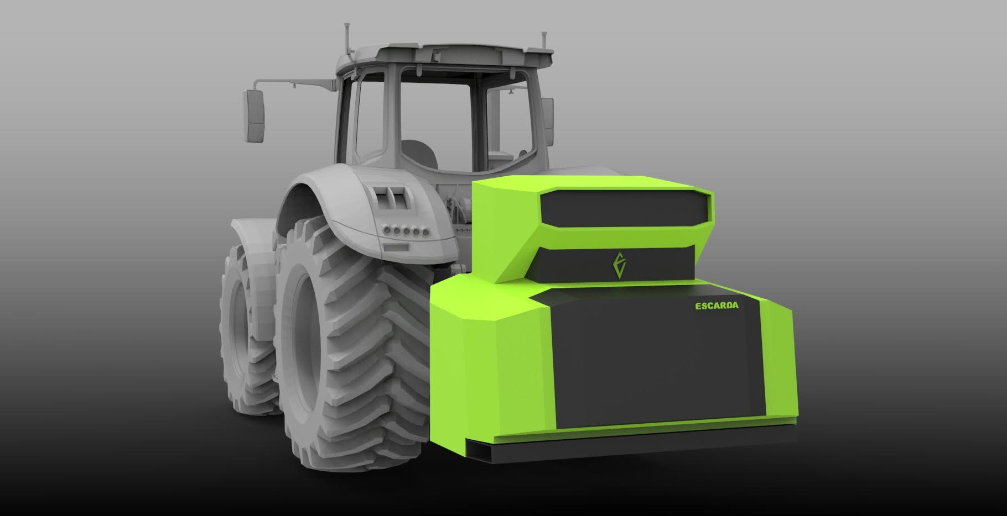

With Escarda's modular system, up to eight laser units can be mounted for large-scale fields.

**Picture 3**

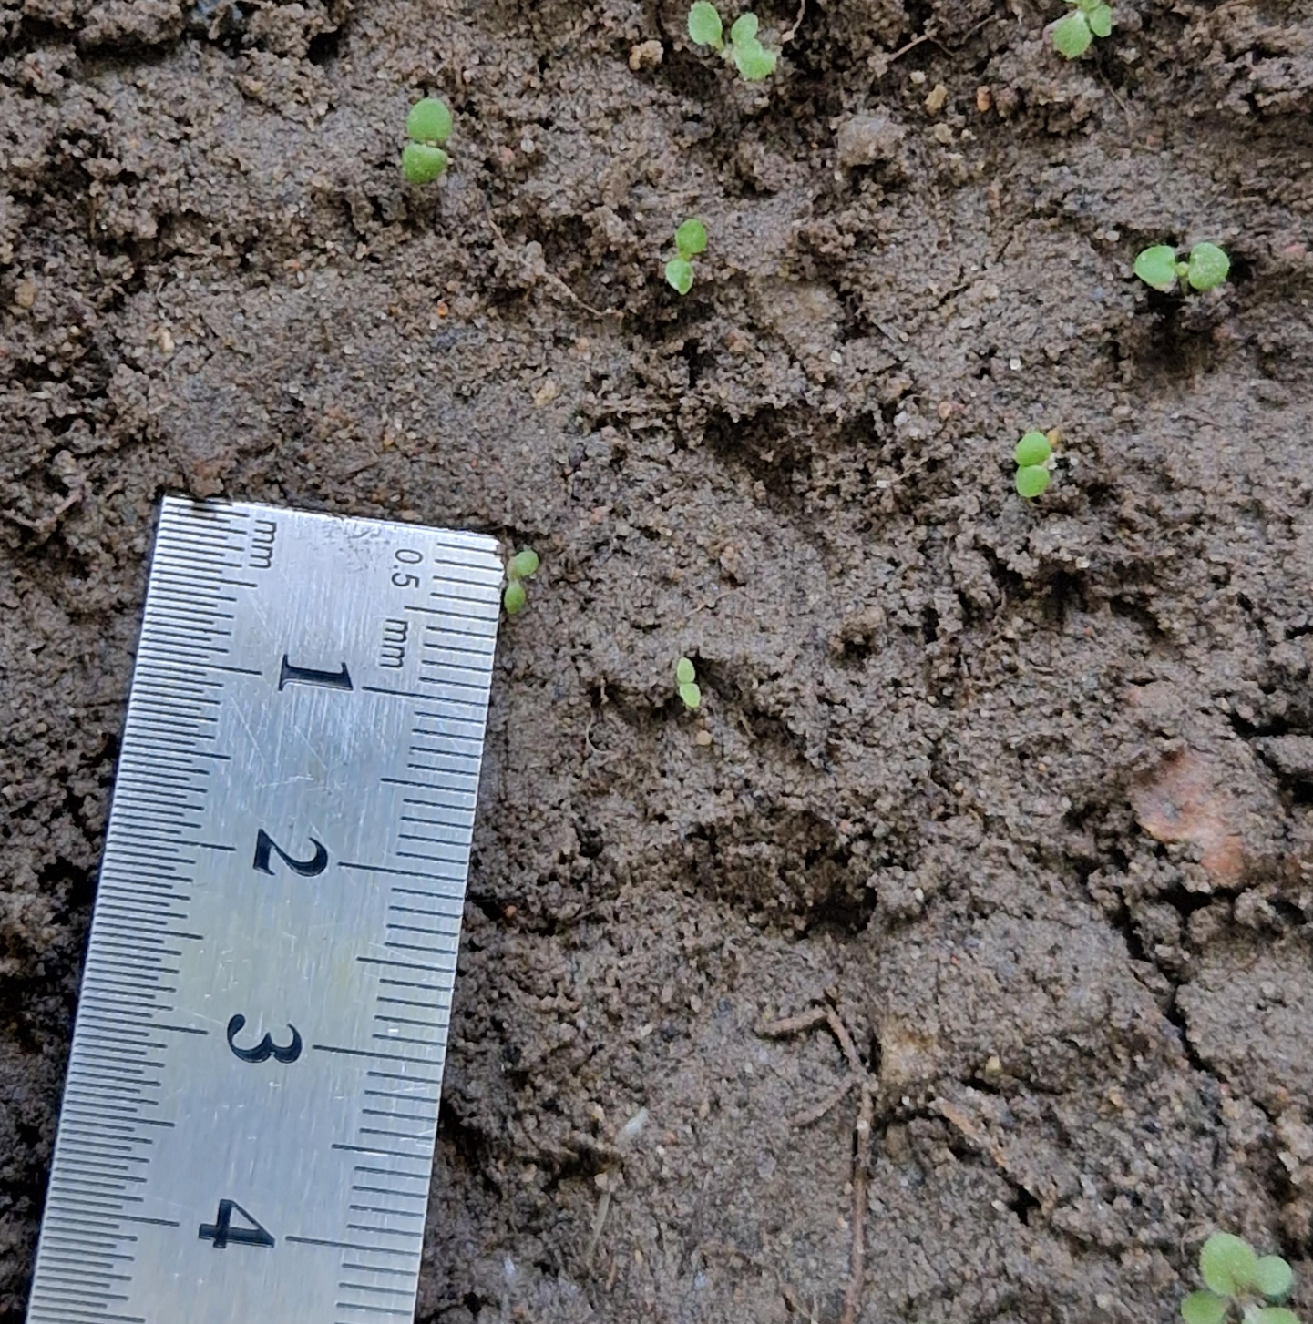

The camera's accuracy detects weeds as small as 3 mm, allowing them to be eliminated at an early stage.

**Picture 4**

Ein Bild, das Blume, Pflanze, Darstellung, Design enthält.

Escarda's system integrates laser technology with a high-precision camera and AI-driven software, enabling herbicide-free weed control.